Національний технічний університет України «КПІ»
Факультет Інформатики та Обчислювальної техніки
Кафедра Обчислювальної Техніки

Лабораторна робота №8
з курсу ТПКС

Виконала:
Студентка 4-го курсу ФІОТ
Групи ІО-92
ГлуШко Ольга



Київ 2012

ЗК №9204₁₀ = 10001111110100₂

Элементный базис: вариант 100 - NOT,3AND

Для построения на заданном базисе использовались результаты минимизации (ДКНФ). Выбрана форма И-НЕ / И.

Проверка работы

Исходный алгоритм:

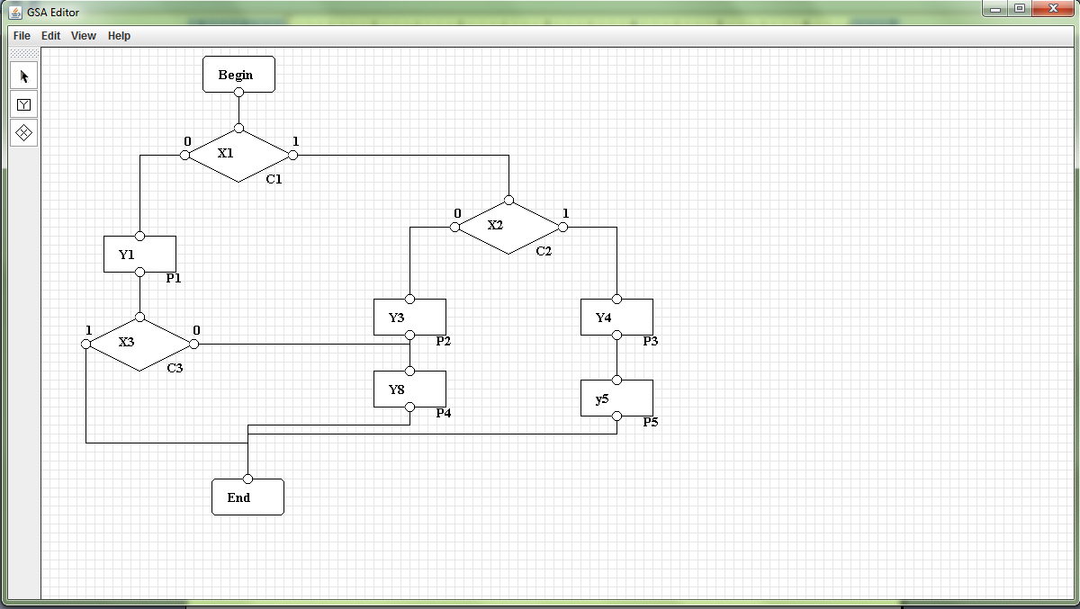

Синтезированный автомат:

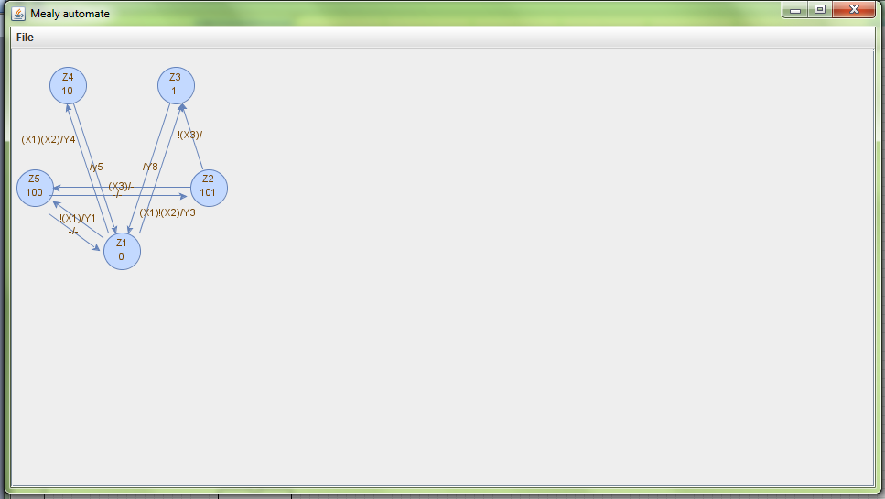

Структурная таблица
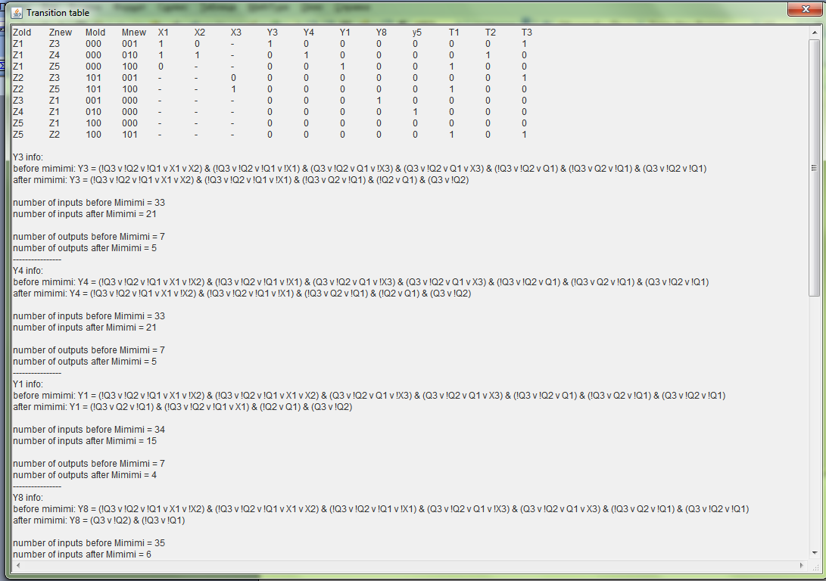

Данные для проверки работы:

Zold Znew Mold Mnew X1 X2 X3 Y3 Y4 Y1 Y8 y5 T1 T2 T3
Z1 Z3 000 001 1 0 - 1 0 0 0 0 0 0 1
Z1 Z4 000 010 1 1 - 0 1 0 0 0 0 1 0
Z1 Z5 000 100 0 - - 0 0 1 0 0 1 0 0
Z2 Z3 101 001 - - 0 0 0 0 0 0 0 0 1
Z2 Z5 101 100 - - 1 0 0 0 0 0 1 0 0
Z3 Z1 001 000 - - - 0 0 0 1 0 0 0 0
Z4 Z1 010 000 - - - 0 0 0 0 1 0 0 0
Z5 Z1 100 000 - - - 0 0 0 0 0 0 0 0
Z5 Z2 100 101 - - - 0 0 0 0 0 1 0 1

Y3 = (!Q3 v !Q2 v !Q1 v X1 v X2) & (!Q3 v !Q2 v !Q1 v !X1) & (!Q3 v Q2 v !Q1) & (!Q2 v Q1) & (Q3 v !Q2)

Y4 = (!Q3 v !Q2 v !Q1 v X1 v !X2) & (!Q3 v !Q2 v !Q1 v !X1) & (!Q3 v Q2 v !Q1) & (!Q2 v Q1) & (Q3 v !Q2)

Y1 = (!Q3 v Q2 v !Q1) & (!Q3 v !Q2 v !Q1 v X1) & (!Q2 v Q1) & (Q3 v !Q2)

Y8 = (Q3 v !Q2) & (!Q3 v !Q1)

y5 = (!Q3 v !Q2 v !Q1) & (!Q2 v Q1) & (Q3 v !Q2)

T1 = (Q3 v !Q2 v Q1 v !X3) & (!Q3 v !Q2 v Q1) & (!Q3 v Q2 v !Q1) & (Q3 v !Q2 v !Q1) & (!Q3 v !Q2 v !Q1 v X1)

T2 = (!Q3 v !Q2 v !Q1 v X1 v !X2) & (!Q3 v !Q2 v !Q1 v !X1) & (!Q3 v Q2 v !Q1) & (!Q2 v Q1) & (Q3 v !Q2)

T3 = (!Q3 v !Q2 v !Q1 v X1 v X2) & (!Q3 v !Q2 v !Q1 v !X1) & (Q3 v !Q2 v Q1 v X3) & (!Q3 v !Q2 v Q1) & (!Q3 v Q2 v !Q1) & (Q3 v !Q2 v !Q1)

Содержимое VHDL-файла:

entity MyEntity is
port (
X1 : in bit;
X2 : in bit;
X3 : in bit;
Y3 : out bit;
Y4 : out bit;
Y1 : out bit;
Y8 : out bit;
y5 : out bit;
T1 : out bit;
Q1 : in bit;
T2 : out bit;
Q2 : in bit;
T3 : out bit;
Q3 : in bit
);
end entity MyEntity;

architecture MyArchitecture of MyEntity is
signal temp_0,temp_1,temp_2,temp_3,temp_5,temp_6,temp_7,temp_8,temp_9,temp_10,temp_12,temp_13,temp_14,temp_15,temp_17,temp_18,temp_19,temp_20,temp_21,temp_22,temp_24,temp_25,temp_27,temp_28,temp_29,temp_30,temp_33,temp_34,temp_36,temp_37,temp_38,temp_40,temp_42,temp_43,temp_44,temp_45,temp_46,temp_48,temp_49,temp_50,temp_52,temp_53,temp_54,temp_55,temp_57,temp_58,temp_59,temp_60,temp_61,temp_62,temp_64,temp_65,temp_66,temp_67,temp_69,temp_70,temp_72,temp_73,temp_74,temp_75,temp_76,temp_77 : bit;
begin
P_0: process(Q3,Q2,Q1)
begin
temp_0 <= (not Q3 and not Q2 and not Q1 );
end process P_0;

P_1: process(X1,X2)
begin
temp_1 <= (X1 and X2 );
end process P_1;

P_2: process(temp_0,temp_1)
begin
temp_2 <= not (temp_0 and temp_1 );
end process P_2;

P_3: process(Q3,Q2,Q1)
begin
temp_3 <= (not Q3 and not Q2 and not Q1 );
end process P_3;

P_5: process(temp_3,X1)
begin
temp_5 <= not (temp_3 and not X1 );
end process P_5;

P_6: process(Q3,Q2,Q1)
begin
temp_6 <= not (not Q3 and Q2 and not Q1 );
end process P_6;

P_7: process(Q2,Q1)
begin
temp_7 <= not (not Q2 and Q1 );
end process P_7;

P_8: process(Q3,Q2)
begin
temp_8 <= not (Q3 and not Q2 );
end process P_8;

P_9: process(temp_2,temp_5,temp_6)
begin
temp_9 <= (temp_2 and temp_5 and temp_6 );
end process P_9;

P_10: process(temp_7,temp_8)
begin
temp_10 <= (temp_7 and temp_8 );
end process P_10;

P_11: process(temp_9,temp_10)
begin
Y3 <= (temp_9 and temp_10 );
end process P_11;

P_12: process(Q3,Q2,Q1)
begin
temp_12 <= (not Q3 and not Q2 and not Q1 );
end process P_12;

P_13: process(X1,X2)
begin
temp_13 <= (X1 and not X2 );
end process P_13;

P_14: process(temp_12,temp_13)
begin
temp_14 <= not (temp_12 and temp_13 );
end process P_14;

P_15: process(Q3,Q2,Q1)
begin
temp_15 <= (not Q3 and not Q2 and not Q1 );
end process P_15;

P_17: process(temp_15,X1)
begin
temp_17 <= not (temp_15 and not X1 );
end process P_17;

P_18: process(Q3,Q2,Q1)
begin
temp_18 <= not (not Q3 and Q2 and not Q1 );
end process P_18;

P_19: process(Q2,Q1)
begin
temp_19 <= not (not Q2 and Q1 );
end process P_19;

P_20: process(Q3,Q2)
begin
temp_20 <= not (Q3 and not Q2 );
end process P_20;

P_21: process(temp_14,temp_17,temp_18)
begin
temp_21 <= (temp_14 and temp_17 and temp_18 );
end process P_21;

P_22: process(temp_19,temp_20)
begin
temp_22 <= (temp_19 and temp_20 );
end process P_22;

P_23: process(temp_21,temp_22)
begin
Y4 <= (temp_21 and temp_22 );
end process P_23;

P_24: process(Q3,Q2,Q1)
begin
temp_24 <= not (not Q3 and Q2 and not Q1 );
end process P_24;

P_25: process(Q3,Q2,Q1)
begin
temp_25 <= (not Q3 and not Q2 and not Q1 );
end process P_25;

P_27: process(temp_25,X1)
begin
temp_27 <= not (temp_25 and X1 );
end process P_27;

P_28: process(Q2,Q1)
begin
temp_28 <= not (not Q2 and Q1 );
end process P_28;

P_29: process(Q3,Q2)
begin
temp_29 <= not (Q3 and not Q2 );
end process P_29;

P_30: process(temp_24,temp_27,temp_28)
begin
temp_30 <= (temp_24 and temp_27 and temp_28 );
end process P_30;

P_32: process(temp_30,temp_29)
begin
Y1 <= (temp_30 and temp_29 );
end process P_32;

P_33: process(Q3,Q2)
begin
temp_33 <= not (Q3 and not Q2 );
end process P_33;

P_34: process(Q3,Q1)
begin
temp_34 <= not (not Q3 and not Q1 );
end process P_34;

P_35: process(temp_33,temp_34)
begin
Y8 <= (temp_33 and temp_34 );
end process P_35;

P_36: process(Q3,Q2,Q1)
begin
temp_36 <= not (not Q3 and not Q2 and not Q1 );
end process P_36;

P_37: process(Q2,Q1)
begin
temp_37 <= not (not Q2 and Q1 );
end process P_37;

P_38: process(Q3,Q2)
begin
temp_38 <= not (Q3 and not Q2 );
end process P_38;

P_39: process(temp_36,temp_37,temp_38)
begin
y5 <= (temp_36 and temp_37 and temp_38 );
end process P_39;

P_40: process(Q3,Q2,Q1)
begin
temp_40 <= (Q3 and not Q2 and Q1 );
end process P_40;

P_42: process(temp_40,X3)
begin
temp_42 <= not (temp_40 and not X3 );
end process P_42;

P_43: process(Q3,Q2,Q1)
begin
temp_43 <= not (not Q3 and not Q2 and Q1 );
end process P_43;

P_44: process(Q3,Q2,Q1)
begin
temp_44 <= not (not Q3 and Q2 and not Q1 );
end process P_44;

P_45: process(Q3,Q2,Q1)
begin
temp_45 <= not (Q3 and not Q2 and not Q1 );
end process P_45;

P_46: process(Q3,Q2,Q1)
begin
temp_46 <= (not Q3 and not Q2 and not Q1 );
end process P_46;

P_48: process(temp_46,X1)
begin
temp_48 <= not (temp_46 and X1 );
end process P_48;

P_49: process(temp_42,temp_43,temp_44)
begin
temp_49 <= (temp_42 and temp_43 and temp_44 );
end process P_49;

P_50: process(temp_45,temp_48)
begin
temp_50 <= (temp_45 and temp_48 );
end process P_50;

P_51: process(temp_49,temp_50)
begin
T1 <= (temp_49 and temp_50 );
end process P_51;

P_52: process(Q3,Q2,Q1)
begin
temp_52 <= (not Q3 and not Q2 and not Q1 );
end process P_52;

P_53: process(X1,X2)
begin
temp_53 <= (X1 and not X2 );
end process P_53;

P_54: process(temp_52,temp_53)
begin
temp_54 <= not (temp_52 and temp_53 );
end process P_54;

P_55: process(Q3,Q2,Q1)
begin
temp_55 <= (not Q3 and not Q2 and not Q1 );
end process P_55;

P_57: process(temp_55,X1)
begin
temp_57 <= not (temp_55 and not X1 );
end process P_57;

P_58: process(Q3,Q2,Q1)
begin
temp_58 <= not (not Q3 and Q2 and not Q1 );
end process P_58;

P_59: process(Q2,Q1)
begin
temp_59 <= not (not Q2 and Q1 );
end process P_59;

P_60: process(Q3,Q2)
begin
temp_60 <= not (Q3 and not Q2 );
end process P_60;

P_61: process(temp_54,temp_57,temp_58)
begin
temp_61 <= (temp_54 and temp_57 and temp_58 );
end process P_61;

P_62: process(temp_59,temp_60)
begin
temp_62 <= (temp_59 and temp_60 );
end process P_62;

P_63: process(temp_61,temp_62)
begin
T2 <= (temp_61 and temp_62 );
end process P_63;

P_64: process(Q3,Q2,Q1)
begin
temp_64 <= (not Q3 and not Q2 and not Q1 );
end process P_64;

P_65: process(X1,X2)
begin
temp_65 <= (X1 and X2 );
end process P_65;

P_66: process(temp_64,temp_65)
begin
temp_66 <= not (temp_64 and temp_65 );
end process P_66;

P_67: process(Q3,Q2,Q1)
begin
temp_67 <= (not Q3 and not Q2 and not Q1 );
end process P_67;

P_69: process(temp_67,X1)
begin
temp_69 <= not (temp_67 and not X1 );
end process P_69;

P_70: process(Q3,Q2,Q1)
begin
temp_70 <= (Q3 and not Q2 and Q1 );
end process P_70;

P_72: process(temp_70,X3)
begin
temp_72 <= not (temp_70 and X3 );
end process P_72;

P_73: process(Q3,Q2,Q1)
begin
temp_73 <= not (not Q3 and not Q2 and Q1 );
end process P_73;

P_74: process(Q3,Q2,Q1)
begin
temp_74 <= not (not Q3 and Q2 and not Q1 );
end process P_74;

P_75: process(Q3,Q2,Q1)
begin
temp_75 <= not (Q3 and not Q2 and not Q1 );
end process P_75;

P_76: process(temp_66,temp_69,temp_72)
begin
temp_76 <= (temp_66 and temp_69 and temp_72 );
end process P_76;

P_77: process(temp_73,temp_74,temp_75)
begin
temp_77 <= (temp_73 and temp_74 and temp_75 );
end process P_77;

P_78: process(temp_76,temp_77)
begin
T3 <= (temp_76 and temp_77 );
end process P_78;

end architecture MyArchitecture;

Результаты симуляции:
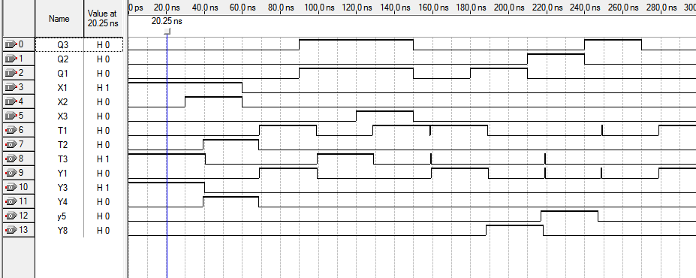

Вывод: т.к. результаты симуляции соответствуют данным структурной таблицы, синтез выполнен корректно.

